ST ALOYSIUS COLLEGE (AUTONOMOUS), MANGALURU – 575 003

Re-accredited by NAAC with ‘A’ Grade with CGPA 3.62/4
Ranked 95 in College Category – 2021 under NIRF, Ministry of Education, Government of India
Recognised as Centre for Research Capacity Building under UGC-STRIDE Scheme
Recognised under the DBT – BUILDER Scheme, Government of India
College with “STAR STATUS” conferred by DBT, Government of India
Recognised by UGC as “College with Potential for Excellence”

CENTRE FOR CULTURAL CONCERN
2020-21

Empowering youth through excellence in education to shape a better future for humankind

About St Aloysius College…..
St Aloysius College belongs to a network of educational institutions administered by the members of the Society of Jesus, a religious order which runs schools, colleges and universities in more than 105 countries in the world. In 1880, nine Jesuits landed in Mangalore at the request made by Mangaloreans to start an institution of quality higher education. St Aloysius College prides itself in its history of 140 years with the motto, “Lucet et Ardet” which means “shine to enkindle”.
The College has inspired countless students to become men and women for and with others thus bring light and joy into their lives. It is for this reason that Jesuit education has become a touchstone for evolving new paradigms in higher education.
Despite its status as a minority institution, the college has imparted high quality education to all sections of society regardless of caste, colour or creed. The College has more than 6,500 students at various levels. Our students have excelled not only in academics but also in cultural, sports & games and many other fields of performance.

Co-curricular and Extra-curricular Activities…..
A good part of our education, the broadening of horizons, inculcation of values, learning to relate to and to deal with others, exercise of participative leadership etc., takes place through cocurricular and extra-curricular activities. The College provides 7 ample opportunities in the form of more than forty Associations and Clubs with the dedicated staff for training and guiding you.

SAHAAYA: Training in Social Responsibility
SAHAAYA is a college programme which creates awareness among students about the social responsibility by engaging in helping the less privileged of the society and engaging in any activity for the promotion of social well-being. For the smooth execution, SAHAAYA activities are implemented through EC/CC Associations which are grouped into FOUR Service Groups:
- Centre for Social Concern (CSC)
- Centre for Environmental Concern (CEC)
- Centre for Cultural Concern (CCC – 1)
- Centre for Civic Concern (CCC – 2)
Associations under Centre for Cultural Concern (CCC – 1)

- Al-Care Association
- Al-Fine Arts Association
- Al-Madhyam Association
- CLC
- Dance Association
- Dramatic Association
- Forum-The Speakers Club
- Heritage Club
- Music Association
- Sports & Games Association
- World Youth Parliament

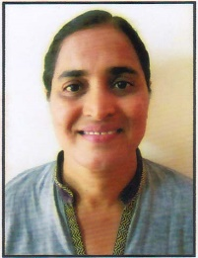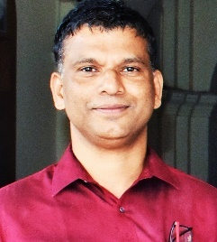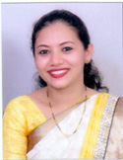
Rev. Dr. Praveen Martis SJ
Principal
Dr Dinesh Nayak
CCC-1 Coordinator
Jennifer Ida Mascarenhas
Dean Extension Services

Ms Sonal Caren DSouza
CCC-1 Coordinator

Activities conducted during the II Semester

Sl. No. | Date | Name of the Activity | Name of the Association
 | 12-06-2021 | Talk on COVID 19 – Myths & Facts | Al - Care Association, SAC
 | 19-06-2021 | Talk on Home Waste Composting
 | 20-06-2021 | Pillow Making
 | 20-06-2021 | Paper Bag Making
 | 11-06-2021 | Digital Poster on Social Awareness | Al-Fine Arts, Association, SAC
 | 25-06-2021 | Environmental Issues and Solutions
 | 20-06-2021 | Save Earth - Painting
 | 20-06-2021 | Wealth Out of Waste
 | 06-06-2021 | Managing Our Mental Health During This Pandemic | CLC, Association, SAC
 | 17-06-2021 | Who Am I?
 | 20-06-2021 | Vertical Garden
 | 20-06-2021 | Creating Educational Video
 | 13-06-2021 | How to Boost Self Confidence | World Youth Parliament Association, SAC
 | 18-06-2021 | Home Remedy
 | 20-06-2021 | Eco-Brick Workshop
 | 15-06-2021 | Streaming Of 2 Documentaries – Plastic Problem & Global Warming | Music Association, SAC
 | 16-06-2021 | Presentation by Students on Topics Assigned
 | 20-06-2021 | Video About Awareness on COVID Pandemic / An Awareness Song
 | 20-06-2021 | Door Mat Making from Old, Unused Clothes.
 | 09-06-2021 | Waste Management | Dramatics Association, SAC
 | 10-06-2021 | COVID 19 - Myths and Facts
 | 20-06-2021 | Vertical Gardening
 | 20-06-2021 | Poster/ Collage Making
 | 27-05-2021 | Social Consciousness – Mr Suhan Alva | Al - Madhyam Association, SAC
 | 05-06-2021 | Talk on Snake Rescue – Mr Atul Pai
 | 20-06-2021 | Poster Making - COVID 19
 | 20-06-2021 | Video Making on Mental Health
 | 15-05-2021 | Role of Ayurveda in Global Health Challenges | Dance Association, SAC
 | 12-06-2021 | Dance for Physical and Mental Well Being
 | 20-06-2021 | Online Dance Coaching Class
 | 20-06-2021 | Remedial Class
 | 20-06-2021 | Making of Soap Dispenser
 | 22-05-2021 | Awareness on Mental Health | Forum-Speakers Club Association, SAC
 | 23-05-2021 | Public Speaking Skills
 | 07-06-2021 | “One Idea That Changed the World” With the Help Of PPT
 | 14-06-2021 | Collage Presentation On “My Role in Spreading Awareness About COVID”
 | 12-08-2021 | COVID19 & Vaccine | Sports Association, SAC
 | 20-06-2021 | Sports Injuries
 | 18-08-2021 | How to Convert the Kitchen Waste to Compost?
 | 05-06-2021 | How to Maintain Mental & Physical Fitness During COVID -19
 | 25-06-2021 | Creation if Collage and Its Presentation | Heritage Club Association, SAC
 | 25-06-2021 | Presentation on Role of Youths in The Conservations of Heritage
 | 20-06-2021 | Compost Making at Home
 | 20-06-2021 | Plantation

Activities conducted during the III Semester

Sl. No. | Date | Name of The Activity | Name of The Association
 | 28/11/2021 | Preventive Healthcare- The Future of Health | Al - Care Association, SAC
 | 05/12/2021 | Mental Health Awareness- The Position of Women.
 | 31/12/2021 | Paper Pen Making
 | 31/12/2021 | Beach Cleaning
 | 25/11/2021 | Silhoutte Animation on Social Awareness | Al-Fine Arts, Association, SAC
 | 12/11/2021 | Environment Protection
 | 31/12/2021 | Save The Girl Child- Art
 | 31/12/2021 | Racial Discrimination-Painting
 | 14/11/2021 | Mission and Jesus | CLC, Association, SAC
 | 8/12/2021 | Presentation of Documentary on Social Ethics
 | 31/12/2021 | Paper Bag Making
 | 31/12/2021 | Eco Bricks
 | 06/12/2021 | Importance of Soft Skills Development in The Professional World | World Youth Parliament Association, SAC
 | 04/12/2021 | Let’s Work Together to Restore Humanity, Beginning with Ourselves
 | 31/12/2021 | PAPER PEN WITH SEED
 | 31/12/2021 | 3 YOGA EXERCISES
 | 01/11/2021 | Address by The Mentor on The Chosen Context - Noncommunicable Diseases | Music Association, SAC
 | 13/11/2021  21/11/2021 | Interactive Sessions on Two Major Non-Communicable Diseases  - Cancer Awareness by Dr. Hemanth, Oncologist  - Heart Diseases by Dr. Jostol Pinto, Cardiologist
 | 31/12/2021 | A Survey on Cancer in And Around Mangalore
 | 31/12/2021 | Writing of An Article on Hypertension
 | 01/11/2021 | Waste Management | Dramatics Association, SAC
 | 03/11/2021 | Eco- Friendly Way of Living Sustainable Life
 | 31/12/2021 | Alvana Clean Drive
 | 31/12/2021 | Alvana Clean Drive
 | 13/11/2021 | Waste Management | Al - Madhyam Association, SAC
 | 8/12/2021 | Sustainable Development
 | 31/12/2021 | Photo Story
 | 31/12/2021 | Clean Drive Phalguni River
 | 08/12/2021 | Exploring The 4th R of Sustainability - Refuse | Dance Association, SAC
 | 10/12/2021 | Dance Work Shop
 | 31/12/2021 | Helping Hands for The Pets
 | 31/12/2021 | Dance for Happiness
 | 31/12/2021 | Yoga for Happiness
 | 22/11/2021 | Common Mistakes in Daily English By Dr Malini Hebbar | Forum-Speakers Club Association, SAC
 | 27/11/2021 | Think Outside the Box by Mr Clinton
 | 31/12/2021 | Paper Bag Making
 | 31/12/2021 | Beach Cleaning
 | 13/12/2021 | First Aid Awareness | Sports Association, SAC
 | 17/12/2021 | Awareness on Sports Nutrition
 | 31/12/2021 | Specific Exercises Game Wise, Warmup and Skill Development
 | 31/12/2021 | Yoga for Life & Its Benefits
 | 04/12/2021 | Health and Hygiene | Heritage Club Association, SAC
 | 11/12/2021 | Presentation on Climate Change: Effects and Solution
 | 31/12/2021 | Eco Brick Making
 | 31/12/2021 | Paper Bag Making and Distribution

AL-CARE ASSOCIATION
We believe that for students it is very important that they are sensitized towards various ongoing social issues during the contemporary times. With Al-Care we aim to sensitize the students on the same. The Presidents of Al-Care for the academic year 2021-2022 and Ms. Lynn Marceline Pinto and Mr. Jessin Baby. The student secretaries are Ms. Vrinda Vinod and Ms. Chaitali S Bhandary. The objective of the association is to impart knowledge on various sensitive social issues to the students through an immersive experience. Issues like Environment protection, climate change, sustainable sourcing, are a few of the issues tackled in Al-Care. Al-Care leaves the students with the belief that they play an important role in bringing about social and environmental change and prepares them to impart the same in their lives.

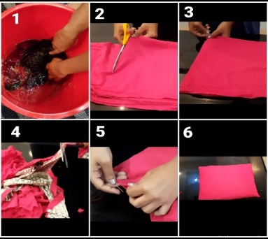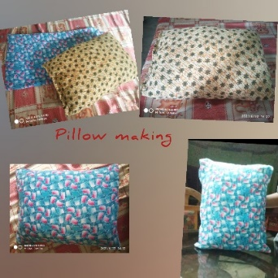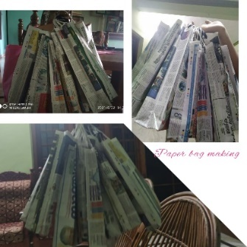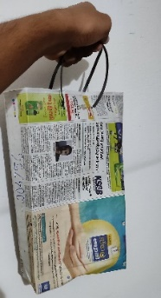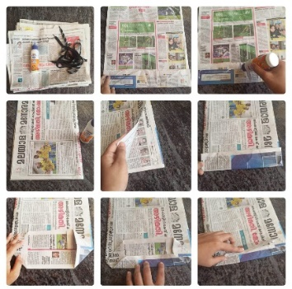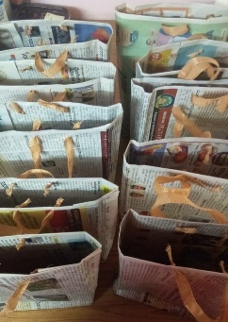

Recycling of used old cloth into beautiful Pillows Paper Bag making …. Easy, convenient and most importantly, free-of-cost bags can be made from old papers in the wink of an eye....

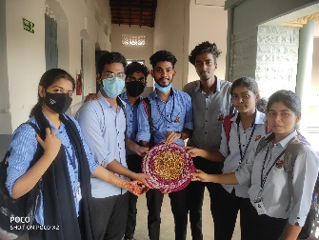
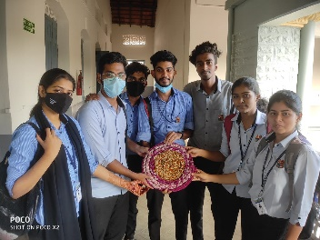
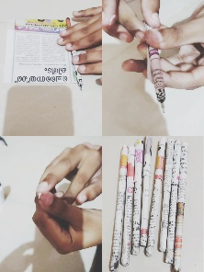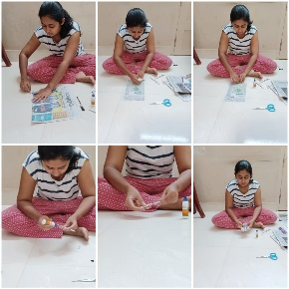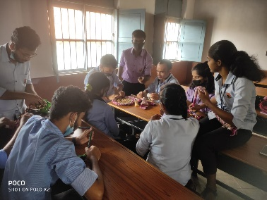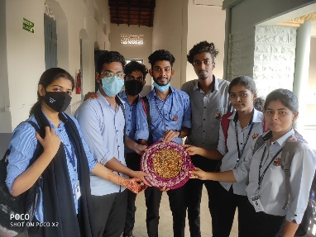

Pape pens (Eco friendly) and Door mates from old cloths…
Rather than throw out old textiles, we have always looking to interesting ways to upcyle them into something useful – It’s time to make a rag rug!

AL-FINE ARTS ASSOCIATION
The Al fine arts association of St. Aloysius College works to help students to bring out their artistic talent. Different forms of art are conducted and encourages students to think creatively and engage and learn about new artistic forms. Students are occasionally clubbed into groups to comprehend and acquire new skills from others and broaden their perspective in the arts. Students are also encouraged to conduct workshops and seminars related to any art form that they specialise in. Pictionary and games are also conducted to improve their creative skills. Various competitions and leagues encourage students to enrich their talent.
The club has 94 student members guided by Larissa Moras (Bsc) and Anisha Pereira (Bsc) as secretaries. They are led by Presidents, Mrs. Suchitra, Ms. Vidya and Ms. Karuna.

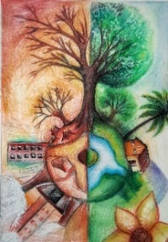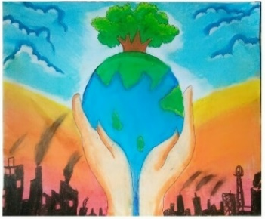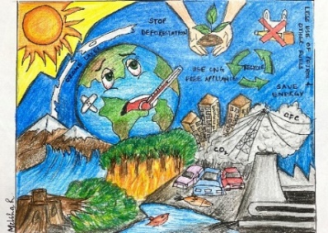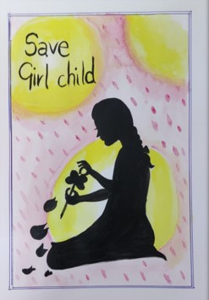
Saving our earth and its environment becomes highly important as it provide us food and water to sustain life.

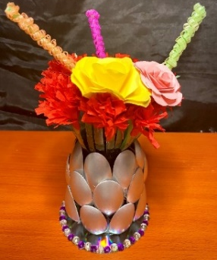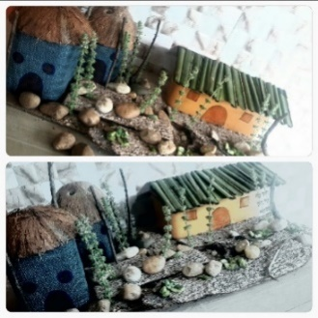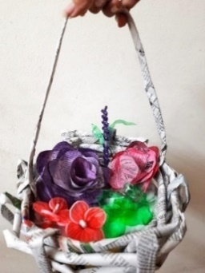
Controlling the amount of waste send into landfills. Enables the students to give this creativity & innovation a shape. Reduces the destruction of forest & other eco – system. Helping the society and nation in conserving our nature
Al-Madhyam Association
Al Madhyam association is a association for students who are passionate about Journalism and media industry. The main objectives of Al Madhyam association is to empower the media aspirants in St Aloysius College with creative talent. The association regularly provides several opportunities to understand the latest developments in the media scenario both in style and content. Al Madhyam association consists of students who enjoy activities like mock press, feature writing, photography, videography, public speaking, debates, ad campaigns etc public relations content writing etc. Using these skills, Al Madhyam association intends to create a vibrant campus culture that appreciates novel thoughts and ideas, the association also conducts regular webinars and seminars for students to attain hands on experience in the field of journalism.
The association has 74 student members lead by Ms Laxmi T (BA) and Ms Brindha KR (B com) as secretaries. They are guided by Ms Divya Deepthi Monteiro and Ms Bhavya Shetty as the presidents.

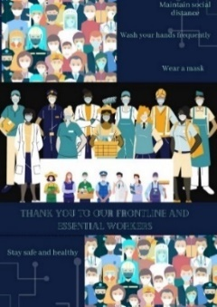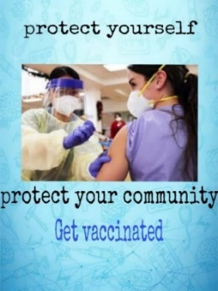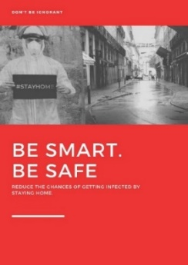
With the COVID-19 pandemic on rise, the need of the hour is universal adoption of safety measures. As prevention is better than cure, it is essential to strictly follow precautionary measures. Keeping this in mind organised poster making activity on COVID-19 awareness through poster with a hard-hitting slogan on it, highlighting the importance of safety measures in curbing the spread of COVID-19
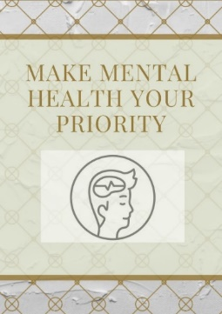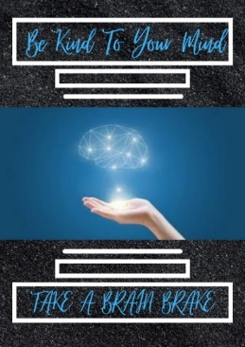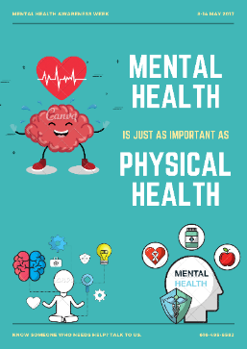
Social media platforms are progressively developing as a rich source of mass communication. Increasing mental health awareness with the help of social media can be a good initiative to reach out to a large number of people in a short time frame.
CLC (Catholic Life Community)
Christian Life Community (CLC) is a way to grow in our faith journey. It is an orientation towards serving Christ in the world through the charism of Ignatian spirituality. Spiritual exercise is the foundation. The preamble of CLC teaches us that there are three divine persons, community is a way of Christian life and public world association. CLC is guided through Ignatian values that offers a vision of life, an understanding of God, a reflective approach to living, a contemplative form of praying, a reverential attitude to our world.

Do you love gardening, but do not have enough space in your house to maintain a garden? Then a vertical garden may be the solution to your problem. Vertical gardening is not only a popular trend these days, but it also has aesthetic, physiological, economic and environmental benefits.

DANCE ASSOCIATION
Dance association is a group of enthusiastic dancers who are getting together to achieve their passion for dance. We dance all genres of dance from Hip Hop to Contemporary, Classical, Bollywood, Folk and many other styles. Whether it be for fun, fitness, or education, we have an opportunity for all to participate and explore the unknown.
The club has 82 student members lead by Chandani and Bhushan Bangera as Secretaries. They are guided by Ms Sandhya Sirsikar and Dr Swetha Mangalath as the Presidents.

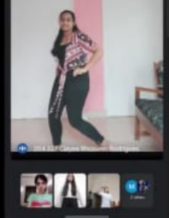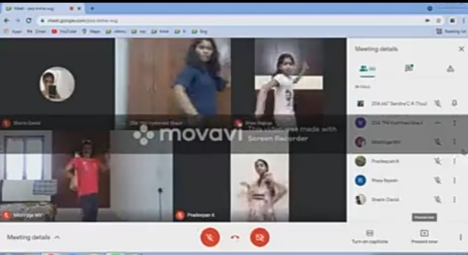
Thanks to technology, many dance studios around the world, have embraced the initiative to offer online dance classes to their students. Implementing a virtual dance platform can be tricky, but it comes with so many benefits

DRAMATIC ASSOCIATION
Dramatics Association works to promote drama culture, learn theatre rules and helps to nurture the dramatic talent of students through various activities and programmes. Drama is represented in the form of a play, mime, street play/dramas etc. Students perform in theatres, give stage performances or perform at different institutions. Different exposures like facial expressions, voice modulation, costume and property designing are given equal importance in the overall activities of the association so that all the students get equal opportunity to present their talent. Various camps/ training programmes/learning sessions are organized for the benefit of the students to showcase their talents. Opportunities are created for students to prepare scripts, direct audio dialogues, compose new music/ songs for students to improve their performing skills.

The club has 70 student members lead by Ms.Amrutha (B.A) and Ms.Avani (B.A) as Secretaries. They are guided by Dr. Dinesh Nayak, Ms Binni Chan, Ms. Sonal D'Souza and Mr Avinash as the Presidents of the Dramatics Association.

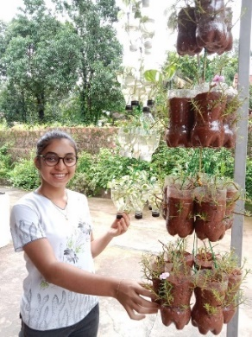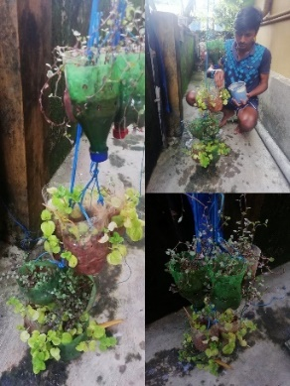
Happiness blooms…!!vertical gardening

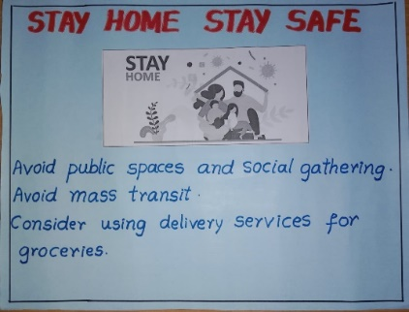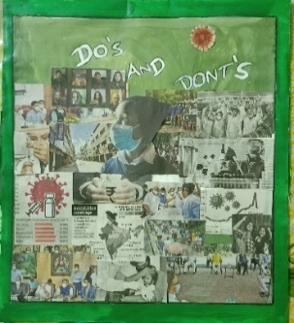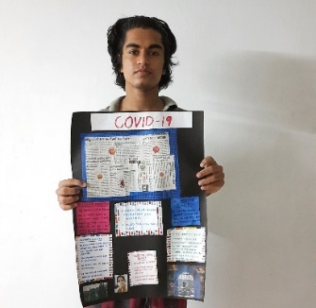

FORUM-THE SPEAKERS CLUB
Forum - The Speakers Club is an association which provides a platform to improve the communication skills of the students. The association aims at training the students in skills like public speaking, debating and hence enable them in becoming good orators.
The club has 82 student members lead by Vijay Krishna and Mazel Fernandes as Secretaries. They are guided by Mr Manoj Fernandes and Ms Crystal as the Presidents.

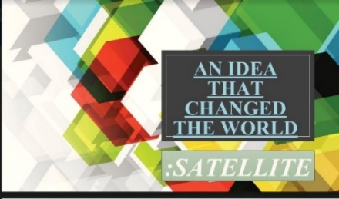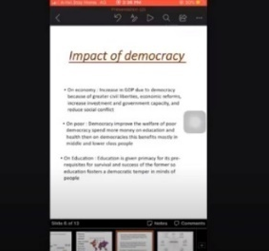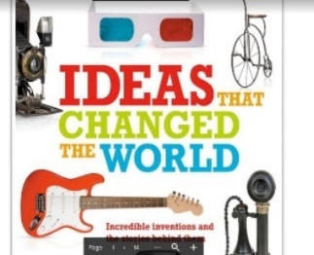
Ideas have catalytic power to change the world. “One idea that changed the world” with the help of PPT

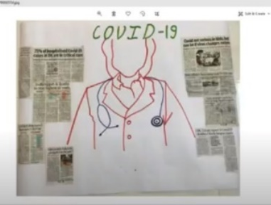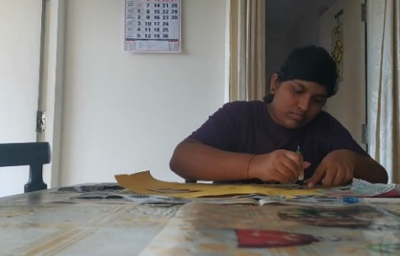
Protecting yourself decreases the risk that you will infect people in your community and around the world. Collage Presentation on “My role in spreading awareness about COVID”

HERITAGE CLUB

COMPOST MAKINGT AT HOME
PLANTATION

MUSIC ASSOCIATION
Music Association works to promote music teaching, learning and helps to nourish the musical talent of students through various activities and programmes. Different styles of both vocal and instrumental music are given equal importance in the overall activities of the association so that all the students get equal opportunity to present their music, learn from others, enhance their own style of music, get introduced to new style and so on. Various musical training programmes/learning sessions to facilitate and enrich the musical talent of students, opportunities to compose new music, events and competitions for students to improve their performing skills, quizzes to enrich the knowledge in music are a few among the activities of the association.
The association has 57 student members lead by Shreyal Vaz (B. Com) and Andrea (BA) as Secretaries. They are guided by Ms.Florin Shelomith Soans, Ms.Amrutha O, Ms.Jyothi Simav Vaz, Ms Felicia Roza Martis as the Presidents.

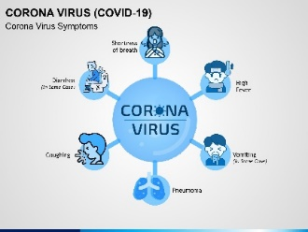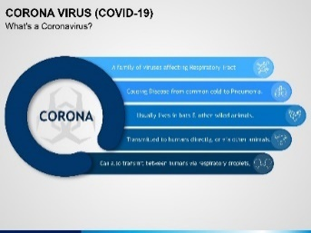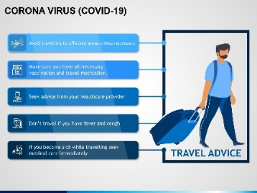
“Awareness on COVID Pandemic” Evidence about social media’s impact on health knowledge, behaviour and outcomes shows that these tools can be effective in meeting individual and population health needs.

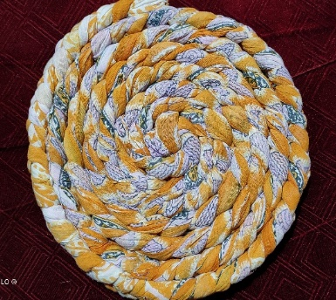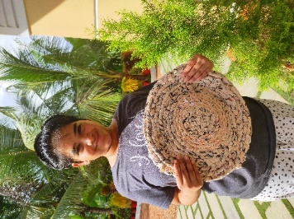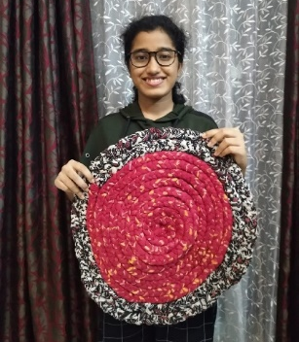
Door mat making from old, unused clothes. People normally discard old clothing. Here we have used an old torn cloth to make a beautiful door mat

SPORTS & GAMES ASSOCIATION

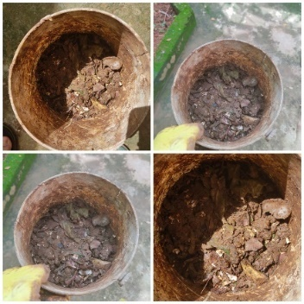
“How to convert the kitchen waste in to compost?” Food waste is composed of organic matter which can be used for composting to make fertilizer. It is an effective and eco-friendly way of disposing of food waste in your kitchen.

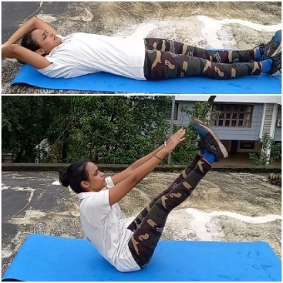
How to maintain mental & physical fitness during COVID19? Regular physical activity benefits both the body and mind. It can reduce high blood pressure, help manage weight and reduce the risk of heart disease, stroke, etc...

WORLD YOUTH PARLIAMENT
The WYP Association works on the project to implement peace through a concrete path of supported dialogue that will facilitate to create choices and proposals within the reach of youth for the restoration of our wounded humanity. The students of the WYP association enter into the atmosphere of their personal and social expertise of their method of expressing themselves and act with others, and examine their use of silence; their bodily, verbal, spiritual, and different varieties of language; the implicit and express models for his or her varieties of expression; the freedom or atmosphere that helps in expressing them freely. (WYPers) from totally different countries work along by hosting conferences and sessions at local , national and international level, holding parliamentary session on problems which may be bridged to bring solutions of unsolved problems and quizzes testing each other's aptitude are some of the works associated here.
The association has 54 students, led by Gahan (Bsc) and Shariya Shaikh (BA) as Secretaries. They are guided by Ms. Priya George and Ms Sharoon D'souza as the President's.

Eco-Brick Workshop
Home Remedy

Film and Video Clips of WYP

